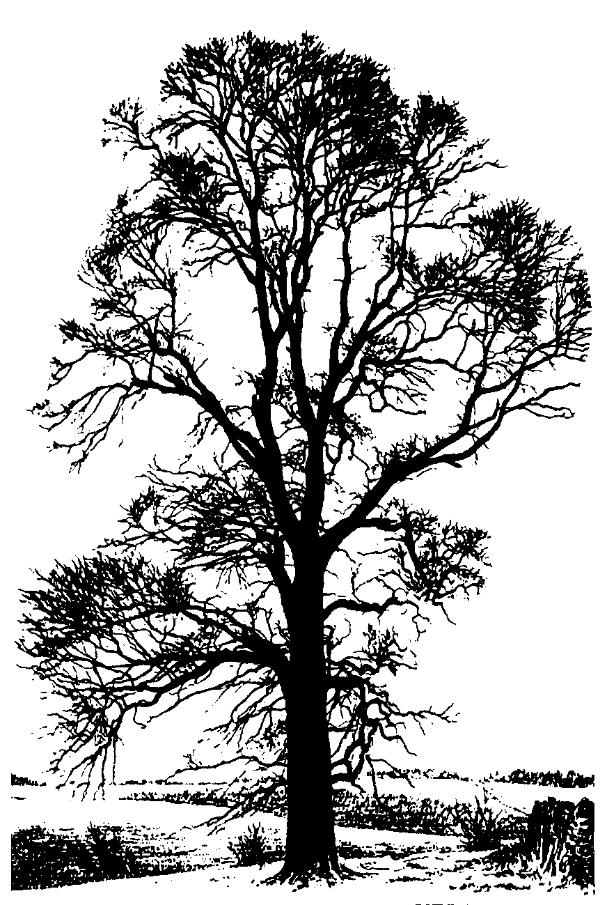

Wychwood Surgery Newsletter

August 2023

Practice changes to report
It is that time of year when we say farewell and Good Luck to our GP Trainees. Dr Anson Yue is a fully qualified GP now and off to Banbury, Drs Priya Sharma & Johnathon McKeown will be moving into their final year placements as ST3’s.

We welcome two new ST2 GP trainees, namely Dr Maryia Saroka and Dr Radhika Nair – we know they will enjoy it here at Wychwood Surgery and know they will be welcomed.

We are a ParkRun Practice!
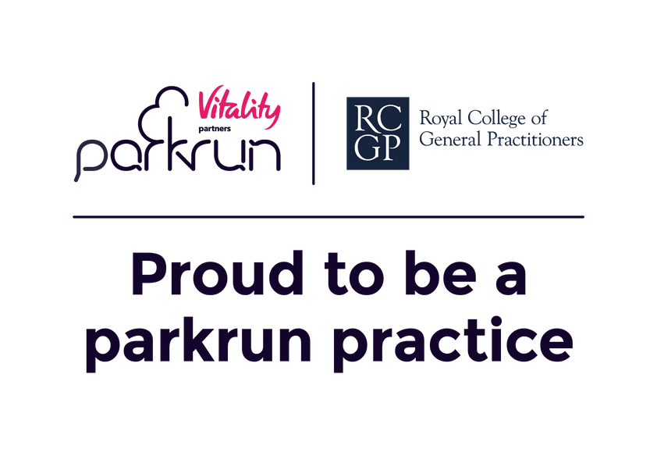

As we are now officially a ParkRun Practice we need to practice what we preach. we are planning to do a Wychwood Surgery ParkRun on Saturday 7th October, – you can attend as a volunteer, come and cheer, walk, jog or run.
ParkRun is a really friendly, sociable event.
https://www.parkrun.org.uk/chippingnortonschool/

0-5km app takes 9 weeks so you have got time.
https://www.nhs.uk/live-well/exercise/running-and-aerobic-exercises/get-running-with-couch-to-5k/

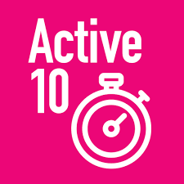
Staying active is important for both your physical and mental health. Doing any sort of exercise throughout the day can make a significant difference, and Active 10 can help you do it. The “Active 10” app records your steps and activity throughout the day, and helps you set goals, giving you tips on how to boost your activity. https://www.nhs.uk/better-health/get-active/

NHS App

Did you know you can manage repeat prescriptions from [your GP surgery name] in the NHS App?
You can easily choose where your prescriptions are sent. So, if you know you'll be away from home or you are moving home, you can change your nominated pharmacy from within the app.
You can also order your prescription at any time that suits you. There’s no need to wait to join a telephone queue or wait until the GP surgery opens.
It’s easy to use, and, if you hit a snag, you can go to ‘Help’ in the top right-hand corner of the app or visit nhs.uk/helpmeapp.
Find out more about the NHS App at: www.nhs.uk/nhsapp

Solar panels are now on the roof and giving us green energy! 
Physiotherapy

Reception can book you into Physio triage appointments in the week and on Saturdays, where appropriate they can refer you to the MSK Health share provision for any secondary care that may be required.

Chipping Norton Health Centre First Aid Unit

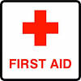
T
his service is provided by South Central Ambulance Service ( SCAS) available for all Wychwood patients (adults and children over 1 year old) and the clinics will be held at Chipping Norton Health Centre. FAU appointments will be available on weekday evenings from 18.40 – 20.00 and on Saturdays from 09.00 – 17.00.
The service has now started and the 20 minute appointment slots will all be face-to-face. Please note that this is not a walk-in service and patients will not be seen without an appointment. - We hope that this service will be well-used and would encourage your appointment booking teams to make sure they know the many different conditions that can be dealt with by the FAU.

- Urine Infections
- Wounds and dressing changes (including sutures)
- Injuries
- Insect Bites
- Ear problems
- Chest Infection
- Sore throat
- Sinusitis
- Sunburn
- Vomiting

Can’t make your appointment?

If you cannot make your appointment and wish to cancel, please let us know so that someone else can have that appointment.

Contact Information

Please do not forget to update the surgery if you change your home or mobile number.

It is essential that we can contact you in an emergency and that we can pass on the correct details to the hospital if you are referred to a consultant.

Closing thoughts….

World Breastfeeding Week - 1st-7th August


World Breastfeeding Week 2023 is focusing on breastfeeding whilst at work. It will show the importance of support in the workplace and parenting norms. The campaign aims to reach politicians, policy makers, employers and families.
https://worldbreastfeedingweek.org/
Breastfeeding can sometimes feel scary and lonely, and you might be struggling with confidence. It’s important to remember that if you have any worries about breastfeeding then you should speak to your midwife or health visitor. To find breastfeeding helplines and support groups, you can use the link below. https://www.nhs.uk/start-for-life/baby/feeding-your-baby/breastfeeding/breastfeeding-help-and-support/

Cycle to Work Day - 3rd August

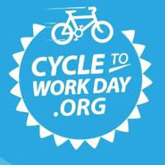
Cycle to Work Day is a day that encourages everyone to get on a bike, whether you ride a bike all the time or haven’t ridden one in years. You don’t have to cycle to work, you can cycle to the shops, do the school run on bicycles, or just go out for a 20-minute bike ride. By taking part, you have the possibility to win prizes such as a gym membership or Fitbit. You just need to join the Cyclescheme “Love to Ride” app and log a ride on 3rd August to be entered into the prize draw. https://www.cyclescheme.co.uk/cycletoworkday
National Allotments Week - 7th-13th August

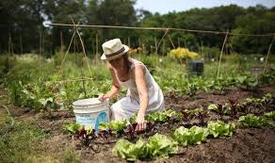
National Allotments Week is used to show the importance of allotments in terms of the environment and for people’s health. Gardening and being outside can help with both physical and mental health and can actually benefit the planet and global warming. The NAS hopes to help people understand the importance of good soil health, as our produce is grown in the soil and allotments that we look after and therefore has an impact on our health. It’s also important to look after the creatures that inhabit the soil. To find out more about National Allotments Week, you can see the link below. https://www.nsalg.org.uk/news-events-campaigns/national-allotments-week/
sMindfulness
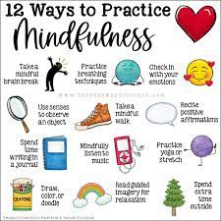
Mindfulness is a technique that’s used to help with stress and self-awareness. Mindfulness can help you feel more aware of what’s happening in the present moment, and it can help you to feel calmer. It also aims to help you to become more self-aware, to feel more able to choose how you respond to your thoughts and feelings, to cope with difficult or unhelpful thoughts, to be kinder to yourself and to manage day-to-day stress. Mindfulness is a skill that you have to practise, but if you work on it regularly, it can be a useful tool.
https://www.mind.org.uk/information...echnique you,your mind, body or surroundings.
Mental wellbeing is important both for yourself and for others. The best ways to improve mental wellbeing are by connecting with people, being physically active, learning new skills, being kind to others and practising mindfulness. To find out more about how you can look after your own mental wellbeing, you can follow the link below. https://www.nhs.uk/mental-health/self-help/guides-tools-and-activities/five-steps-to-mental-wellbeing/

Are you a handy person?

Can you help us with some jobs around the practice, please contact Zoe our Practice Manager at zoe.grisenthwaite1@nhs.net who can let you know what we need doing.

